**HDFS Commands**

I have discussed about what is HDFS, its features and architecture in my [***previous blogs***](http://www.edureka.co/blog/hdfs-tutorial?utm_source=blog&utm_medium=content-link&utm_campaign=hdfs-commands). In this blog, I will talk about the HDFS commands using which you can access the Hadoop File System.

So, let me tell you the important HDFS commands and their working which are used most of the times when working with Hadoop File System.

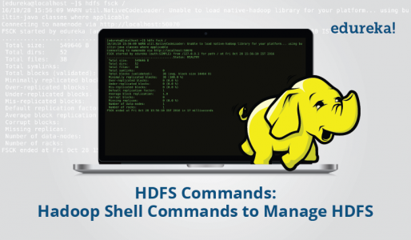

**fsck**

HDFS Command to check the health of the Hadoop file system.

***Command:*** hdfs fsck /

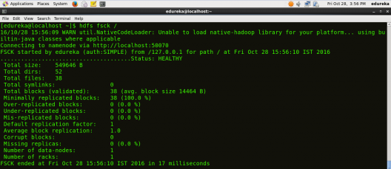

**ls**

HDFS Command to display the list of Files and Directories in HDFS.

***Command:*** hdfs dfs –ls /

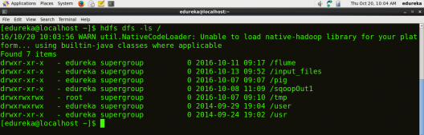

**mkdir**

HDFS Command to create the directory in HDFS.

***Usage:***hdfs dfs –mkdir /directory_name

***Command:*** hdfs dfs –mkdir /new_edureka

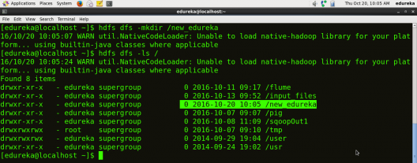

**Note:** Here we are trying to create a directory named “new_edureka” in HDFS.

**touchz**

HDFS Command to create a file in HDFS with file size 0 bytes.

***Usage:*** hdfs dfs –touchz /directory/filename

***Command:*** hdfs dfs –touchz /new_edureka/sample.

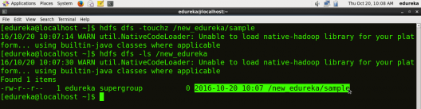

**Note:** Here we are trying to create a file named “sample” in the directory   “new_edureka” of  hdfs with file size 0 bytes.

**du**

HDFS Command to check the file size.

***Usage:*** hdfs dfs –du –s /directory/filename

***Command:*** hdfs dfs –du –s /new_edureka/sample

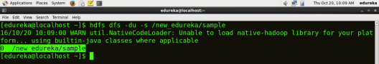

**cat**

HDFS Command that copies source paths to stdout.

***Usage:***hdfs dfs –cat /path/to/file_in_hdfs

***Command:*** hdfs dfs –cat /new_edureka/test

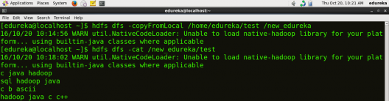

**text**

HDFS Command that takes a source file and outputs the file in text format.

***Usage:*** hdfs dfs –text /directory/filename

***Command:*** hdfs dfs –text  /new_edureka/test

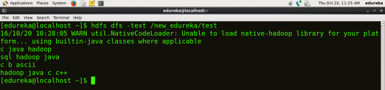

**copyFromLocal**

HDFS Command to copy the file from Local file system to HDFS.

***Usage:*** hdfs dfs -copyFromLocal <localsrc> <hdfs destination>

***Command:*** hdfs dfs –copyFromLocal /home/edureka/test /new_edureka



**Note:**Here test is the file present in the local directory /home/edureka and after the command gets executed the test file will be copied in /new_edureka directory of HDFS.

**copyToLocal**

HDFS Command to copy the file from HDFS to Local File System.

***Usage:*** hdfs dfs -copyToLocal <hdfs source> <localdst>

***Command:***hdfs dfs –copyToLocal /new_edureka/test /home/edureka

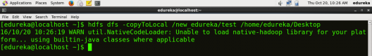

**Note:** Here test is a file present in the new_edureka directory of HDFS and after the command gets executed the test file will be copied to local directory /home/edureka

**put**

HDFS Command to copy single source, or multiple sources from local file system to the destination file system.

***Usage:***hdfs dfs -put <localsrc> <destination>

***Command:*** hdfs dfs –put /home/edureka/test /user

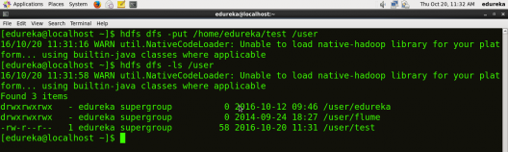

**Note:**  The command copyFromLocal is similar to put command, except that the source is restricted to a local file reference.

**get**

HDFS Command to copy files from hdfs to the local file system.

***Usage:*** hdfs dfs -get <src> <localdst>

***Command:*** hdfs dfs –get /user/test /home/edureka

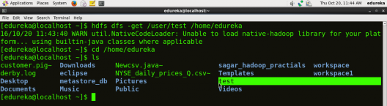

**Note:** The command copyToLocal is similar to get command, except that the destination is restricted to a local file reference.

**count**

HDFS Command to count the number of directories, files and bytes under the paths that match the specified file pattern.

***Usage:*** hdfsdfs -count <path>

***Command:*** hdfs dfs –count /user

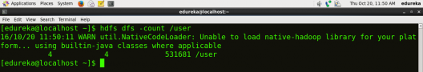

**rm**

HDFS Command to remove the file from HDFS.

***Usage:*** hdfs dfs –rm <path>

***Command:***  hdfs dfs –rm /new_edureka/test

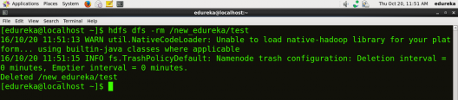

**rm -r**

HDFS Command to remove the entire directory and all of its content from HDFS.

***Usage:*** hdfs dfs -rm -r <path>

***Command:*** hdfs dfs -rm -r  /new_edureka

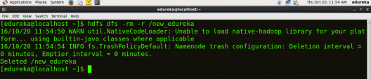

**cp**

HDFS Command to copy files from source to destination. This command allows multiple sources as well, in which case the destination must be a directory.

***Usage:*** hdfs dfs -cp <src> <dest>

***Command:*** hdfs dfs -cp /user/hadoop/file1 /user/hadoop/file2

***Command:*** hdfs dfs -cp /user/hadoop/file1 /user/hadoop/file2 /user/hadoop/dir

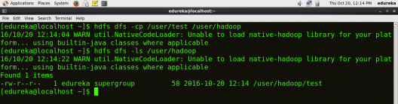

**mv**

HDFS Command to move files from source to destination. This command allows multiple sources as well, in which case the destination needs to be a directory.

***Usage:***  hdfs dfs -mv <src> <dest>

***Command:*** hdfs dfs -mv /user/hadoop/file1 /user/hadoop/file2

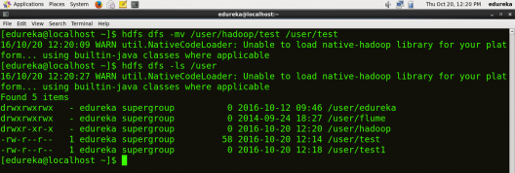

**expunge**

HDFS Command that makes the trash empty.

**Command:** hdfs dfs -expunge

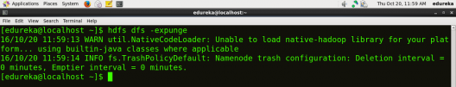

**rmdir**

HDFS Command to remove the directory.

***Usage:*** hdfs dfs -rmdir <path>

***Command:*** hdfs dfs –rmdir /user/hadoop

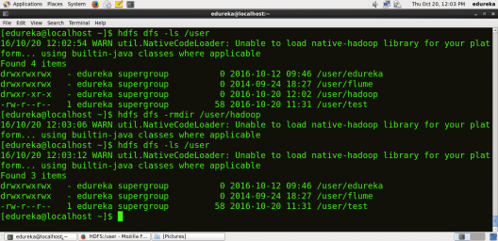

**usage**

HDFS Command that returns the help for an individual command.

***Usage:*** hdfs dfs -usage <command>

***Command:*** hdfs dfs -usage mkdir

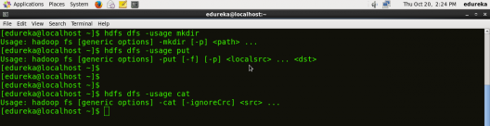

**Note:** By using usage command you can get information about any command.

**help**

HDFS Command that displays help for given command or all commands if none is specified.

***Command:*** hdfs dfs -help

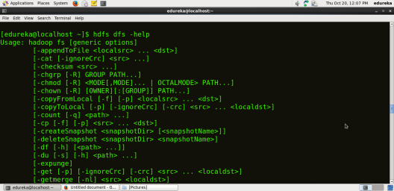

This is the end of the HDFS Commands blog, I hope it was informative and you were able to execute all the commands. For more HDFS Commands, you may refer Apache Hadoop documentation [**here**](https://hadoop.apache.org/docs/r2.7.2/hadoop-project-dist/hadoop-common/FileSystemShell.html?utm_source=blog&utm_medium=content-link&utm_campaign=hdfs-commands).

[<< Previous Blog](http://www.edureka.co/blog/install-hadoop-single-node-hadoop-cluster?utm_source=blog&utm_medium=blog-cta&utm_campaign=hdfs-commands-p)   [Next Blog >>](http://www.edureka.co/blog/hadoop-ecosystem?utm_source=blog&utm_medium=blog-cta&utm_campaign=hdfs-commands-n)